Student Name 1: Curtis Collins
Student Name 2: Lee-Ong Sim
IP Address block: 172.20.__8__.__0____

Topology Diagram
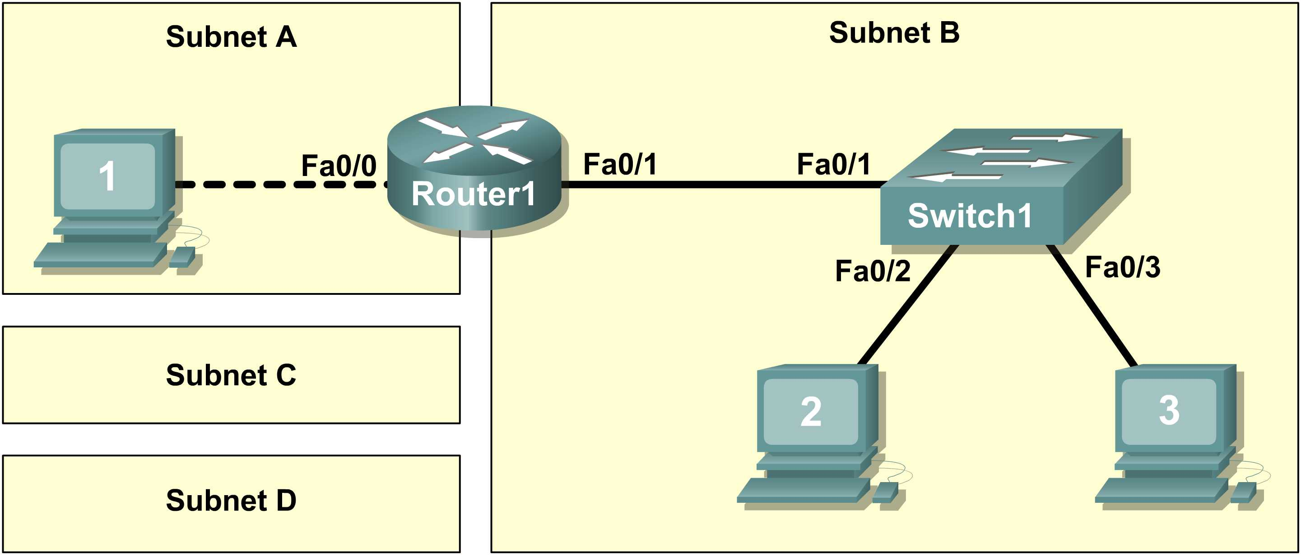
Figure 1. Cabling the Network

Task 1: Design the Logical Network.
Step 1-4: Design SubnetD address block.
Q1-Q4
Sub Network | Network Address | x.x.x.x Mask | /nn Mask | First Host Address | Last Host Address | Broadcast
D | 172.20.8.0 | 255.255.255.128 | /25 | 172.20.8.1 | 172.20.8.126 | 172.20.8.127
C | 172.20.8.128 | 255.255.255.192 | /26 | 172.20.8.129 | 172.20.8.190 | 172.20.8.191
B | 172.20.8.192 | 255.255.255.248 | /29 | 172.20.8.193 | 172.20.8.198 | 172.20.8.199
A | 172.20.8.200 | 255.255.255.252 | /30 | 172.20.8.201 | 172.20.8.202 | 172.20.8.203

Task 2: Configure the Physical Lab Topology.
Step 2: Network connections.

Q5 Host1 MAC Address : 00:01:64:E6:E0:89

Q6-Q11
From | To | Cable Type
Host_1 | Router_1 Fa0/0 | Crossover
Router_1 Fa0/1 | Switch_1 | Straight-Through
Host2 | Switch_1 | Straight-Through
Host3 | Switch_1 | Straight-Through
Task 3: Configure the Logical Topology.
Step 1: Document logical network settings.
Q12
Host1 (use first address from subnet A)
IP Address | 172.20.8.201
IP Mask | 255.255.255.252
Gateway Address | 172.20.8.202
Host2 (use first address from subnet B)
IP Address | 172.20.8.193
IP Mask | 255.255.255.248
Gateway Address | 172.20.8.198
Host3 (use second address from subnet B)
IP Address | 172.20.8.194
IP Mask | 255.255.255.248
Gateway Address | 172.20.8.198
Router1 Interface Fa0/0
IP Address | 172.20.8.202
IP Mask | 255.255.255.252
Router1 Interface Fa0/1
IP Address | 172.20.8.198
IP Mask | 255.255.255.248
Task 4: Verify Network Connectivity.
Q13 [2 marks]
From | To | Source IP | Target IP | Ping Results
Host1 | Gateway (Router1, Fa0/0) | 172.20.8.201 | 172.20.8.202 | Success
Host1 | Router1, Fa0/1 | 172.20.8.201 | 172.20.8.198 | Success
Host1 | Host2 | 172.20.8.201 | 172.20.8.193 | Success
Host1 | Host3 | 172.20.8.201 | 172.20.8.194 | Success
Host2 | Host3 | 172.20.8.193 | 172.20.8.194 | Success
Host2 | Gateway (Router1, Fa0/1) | 172.20.8.193 | 172.20.8.198 | Success
Host2 | Router1, Fa0/0 | 172.20.8.193 | 172.20.8.202 | Success
Host2 | Host1 | 172.20.8.193 | 172.20.8.201 | Success
Host3 | Host2 | 172.20.8.194 | 172.20.8.193 | Success
Host3 | Gateway (Router1, Fa0/1) | 172.20.8.194 | 172.20.8.198 | Success
Host3 | Router1, Fa0/0 | 172.20.8.194 | 172.20.8.202 | Success
Host3 | Host1 | 172.20.8.194 | 172.20.8.201 | Success

Q14 In the above scenario, how can a malfunctioning Gateway be detected?
You can find out if the gateway is malfunctioning by pinging it. If the ping is successful, the problem lies elsewhere. If the ping times out, then there is a malfunction along the PATH to the gateway, or in the gateway itself.
Task 6: Challenge [3 BONUS marks]
Ask your instructor to introduce one or two problems in your network , then fix them.
- Perform a good visual inspection. Look at the status of the device ports by hovering your mouse over the device icon.

Use the table provided in Task 3 to identify failed connectivity. List the problems:
The first problem encountered was that the wrong cable was used to connect Host 1 to Router1.
The second problem we encountered was that the ip addresses for Interface 0/0 and 1/0 on Router1 were switched.
Write down your proposed solution(s):
We propose to switch the current straight-through cable connecting Host1 and Router1 with a crossover cable instead. We will then proceed to revert the IP addresses for interfaces 0/0 and 1/0 on Router1, back to their original addresses of 172.20.8.202 (0/0) and 172.20.8.198 (1/0)
Test your solution. If the solution fixed the problem, document the solution. If the solution did not fix the problem, continue troubleshooting.
Our proposed solution worked just fine and dandy, flawless even, and thus we shall continue to dominate the networking world.

Note: At this point you should call your lab instructor to have your lab check in.

To be filled in by Lab Instructor

☺ IP subnetting ☺ Connectivity
☺ Cabling ☺ Problem / Fix

Lab Instructor Mr. Anderson

